**RESUME**

*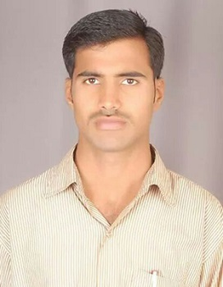Sharath Kumar*

S/o Chandregowda, Thuraganahalli (v),

Kadalu (Po), Alur (Tq), Hassan (d).573213

E-mail ID :sharathkumar914@gmail.com

Graduation : BA (H.P.S)

Year of graduation : 2012-2013

Aggregate : 59%

Phone Number : +918970459638

# EDUCATIONAL DETAILS:

|  |  |  |  |  |  |
| --- | --- | --- | --- | --- | --- |
| **Sl No** | **Qualification** | **Institution** | **Board or University** | **Year** | **Percentage** |
| 1 | B.A | Govt College  Hassan | Mysore University | 2013 | 59.00% |
| 2 | PUC | Govt Junior Pu College  Allur | Pre-University | 2010 | 45.00% |
| 3 | SSLC | YHS Kandalli | Kseeb | 2008 | 37.00% |

**ACHIEVEMENTS**

* ***BEST PERFORMANCE AWARD*** in business development (3 times awarded by ICICI)
* Best NCC cadet.
* Gold medal in shooting (in NCC troop).

**CAREER OBJECTIVE**  
 To effectively utilize my skills in the field of business development and Research myself and for the company in which I am working with utmost dedication.

**AREA OF INTEREST**

Marketing, Business Development, Quality management.

**PERSONALITY TRAITS**Leadership quality.  
Team spirit.  
Smart worker.  
Interested in updating knowledge through continuous learning.

Accept difficulties as challenges

**CURRENT EXPERIENCE**

1. **Organization : ICICI BANK.**

**Designation : OFFICER**

**EXPERIENCE : 2 YEARS**

1. **Organization : Kotak Mahindra Bank.**

**Designation : Assistant Manager**

**EXPERIENCE : 5 Months**

**EXTRA CURRICULAR ACTIVITIES**

SPORTS, NSS, NCC,Good knowledge incomputer.

**PERSONAL DETAILS**:

Name : SHARATH KUMAR

Father’s name : CHANDREGOWDA

Date of birth : 23-JULY-1991

Sex : Male.

Nationality : Indian

Permanent Address : Sharath Kumar

S/o Chandregowda Thuraganahalli (v)

Kadalu (Po), Alur (Tq), Hassan (D) 573213.

Languages Known : English, and Kannada.

Name of Institution : Government Arts College Hassan.

I**Sharath Kumar**hereby declare that above information is true to the best of my knowledge and belief.

Date : Signature

Place :

**Sharath Kumar**